**Abstraction in Java**

Abstraction is a process of hiding the implementation details and showing only functionality to the user.

Another way, it shows only essential things to the user and hides the internal details, for example, sending SMS where you type the text and send the message. You don't know the internal processing about the message delivery.

**There are two ways to achieve abstraction in java**

1. Abstract class (0 to 100%)
2. Interface (100%)

**Abstract class in Java**

A class which is declared with the abstract keyword is known as an abstract class in Java. It can have abstract and non-abstract methods (method with the body).

* An abstract class must be declared with an abstract keyword.
* It can have abstract and non-abstract methods.
* It cannot be instantiated.
* It can have constructors and static methods also.
* It can have final methods which will force the subclass not to change the body of the method.

**next →← pre**

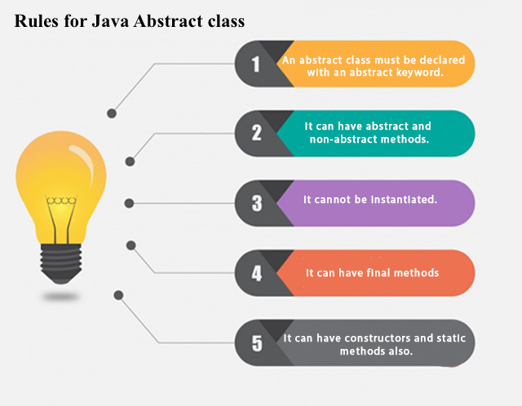

**Example of abstract class**

package ex;

abstract class example11{

abstract void m1();

**void m2(){**

**System.*out*.println("hello");**

**}**

}

public class absEx extends example11{

public void m1(){

System.*out*.println("hi");

}

P ublic static void main(String[] args) {

absEx a= new absEx();

a.m1();

a.m2();

}

}

**Interface in Java**

An **interface in java** is a blueprint of a class. It has static constants and abstract methods.

The interface in Java is *a mechanism to achieve abstraction*. There can be only abstract methods in the Java interface, not method body. It is used to achieve abstraction and multiple inheritance in Java.

There are mainly three reasons to use interface. They are given below.

* It is used to achieve abstraction.
* By interface, we can support the functionality of multiple inheritance.
* It can be used to achieve loose coupling.

a class extends another class, an interface extends another interface, but a **class implements an interface**.

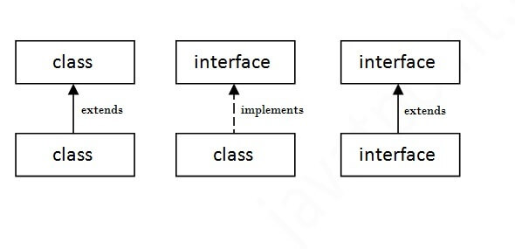

**Java Interface Example:**

package ex;

interface Example{

abstract void add();

}

public class InterfaceEx implements Example {

public void add(){

System.*out*.println("hello");

}

public static void main(String[] args) {

InterfaceEx i=new InterfaceEx();

i.add();

}

}